**Australian Islamic College 2021**

**ATAR Chemistry Units 3 and 4**

**Task 8 (Weighting: 5%)**

**Organic Chemistry**

Test Time: 50 minutes

Please do not turn this page until instructed to do so.

|  |  |
| --- | --- |
| **First Name** | **Surname** |
|  |  |

|  |
| --- |
| **Teacher** |
|  |

|  |  |
| --- | --- |
| **Mark / 47** | **Percentage** |
|  |  |

Equipment allowed: Pens, pencils, erasers, whiteout, rulers and non-programmable calculators permitted by the Schools Curriculum and Standards Authority.

**Special conditions**:

2 marks will be deducted for failing to write your full name on this test paper.

**Teacher help:** Your teacher can only help you during your test in one situation. If you believe there is a mistake in a question show your teacher and your teacher will tell you if there is a mistake in the question and if appropriate, how to fix that mistake.

**Spelling of Science words** must be correct. Unless otherwise indicated, science words with more than one letter wrong (wrong letter and/or wrong place) will be marked wrong. The spelling of IUPAC names must be exactly correct.

Unless otherwise stated, **equations** must be written balanced and with correct state symbols or they will be marked wrong.

For questions worth more than one mark involving calculations, your working out must be shown. Calculations that cannot be easily understood by the marker or that do not follow a logical sequence from top of the page to the bottom of the page will lose marks.

The final answer of calculations worth more than one mark must be stated to the appropriate number of significant figures.

Follow-on marks will not be paid.

Questions must be answered in this booklet.

**Part 1: Multiple Choice Section 4 Marks**

1. Which of the following compounds is the most basic?

A. Ethane

B. Ethanol

C. Ethanamine

D. Ethyl ethanoate

2. Which compound reacts readily with sodium hydrogen carbonate?

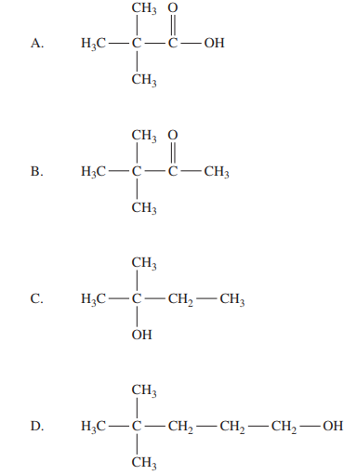

3. All the following compounds have similar molar masses.

Which has the highest boiling point?

A. Butane

B. Ethanoic acid

C. Propan-1-ol

D. Propanone

4. Which class of organic compound must contain at least three carbon atoms?

A. Aldehydes

B. Alkenes

C. Carboxylic acids

D. Ketones

**Part 2: Short Answer Section 43 Marks**

1(a). Complete the table below by selecting the chemical term from the following list that best matches the definition/description provided. (2 marks)

List: alkane, alkene, amide, structural isomer, geometrical isomer, functional group, saturated hydrocarbon, Amines

|  |  |
| --- | --- |
| **Definition/description** | **Chemical term** |
| A family of Organic compounds, that are derivates of Carboxylic acids and Amines. |  |
| A specific arrangement of atoms in an organic compound that determines the reactions of that compound |  |

(b). Name the organic substance with the following structure: (2 marks)

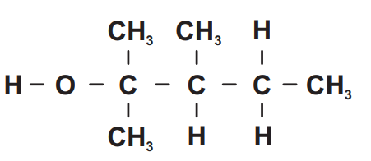

(c). A substance of molecular formula C3H8O has two structural isomers, P and Q, both of which release hydrogen gas when reacted with sodium metal.

Oxidation of P and Q by an acidified solution of K2Cr2O7 resulted in two new isomeric products, R and S respectively, both with the molecular formula C3H6O.

R was able to be further oxidised with the same acidified solution of K2Cr2O7 to a product T with the molecular formula C3H6O2, while S could not be further oxidised in the same manner.

Apply your knowledge of organic chemistry to write structural formulas for compounds P, Q, R, S and T. Please show all the bonds and atoms.

Justify your response. (7 marks)

1. (a). State the IUPAC name for the following substance (2 marks)

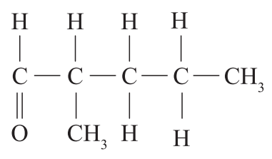

(b). Pentanol, propyl acetate, pentanoic acid and ethyl propanoate all contain five carbon

atoms. These four compounds are mixed in a flask and then separated by fractional

distillation.

Which compound would be most likely to remain in the flask? Explain in detail

(4 marks)

1. (a). The structural formula for 2-methylpropan-2-ol is shown in the table. Draw one structural isomer of this alcohol and state its name.

Please show all the bonds and atoms. (2 marks)

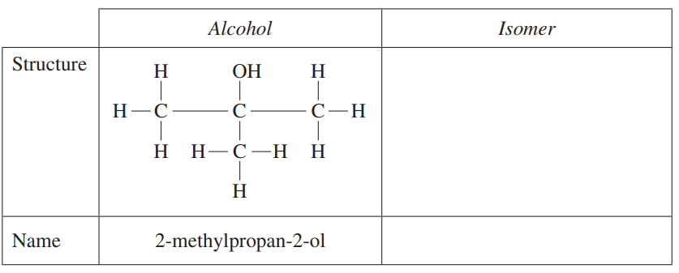

The structural formulae for two compounds are shown below.

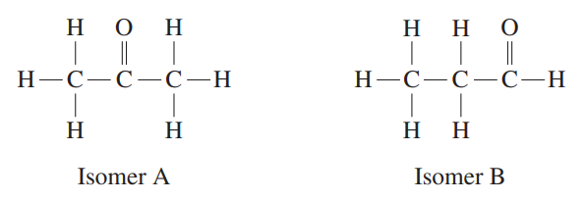

(b). Name the Functional groups of the above substances. (2 marks)

Isomer A

Isomer B

(c). Are these substances soluble in water or hexene? Explain your answer in detail.

(4 marks)

1. The flow chart shows reactions involving 5 different compounds **A-E** (5 marks)

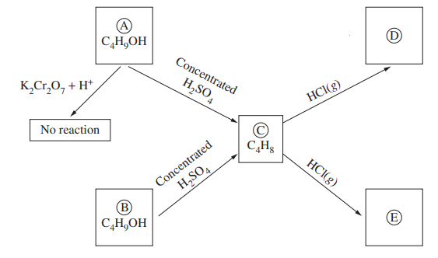

Please show all the bonds and atoms.

Draw the structure of each compound A to E in the corresponding space provided.

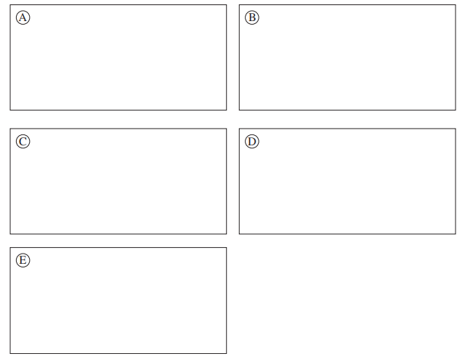

1. A particular triglyceride found in beef, Compound A, contains three different fatty acid chains:

palmitic, stearic and oleic. Compound A undergoes hydrolysis in the human body before its nutrients can be absorbed. The reaction pathway below represents this reaction.

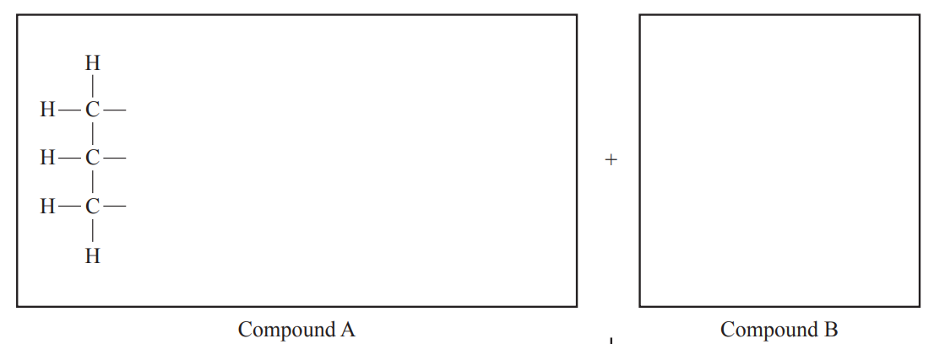

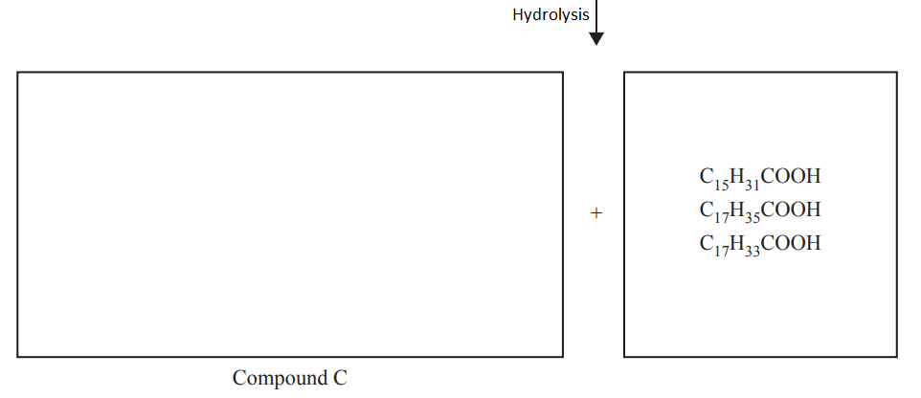

(a). Complete the structure of Compound A in the box provided. (2 marks)

(b). Write the formula of Compound B and its correct stoichiometric ratio in the box provided. (1 mark)

(c). Draw the structural formula of the product molecule, Compound C, in the box provided.

(1 marks)

(d). Sodium Salts of C15H31COOH are called soaps. Describe the cleaning action of soaps in detail. (3 marks)

**Empirical formula.**

Garlics and onions have very distinctive pungent smell. The smell can linger on a person's breath for hours and even overnight, which discourages some people from eating these vegetables.

The smell of these substances is due to a combination of many compounds. One of these compounds contains carbon, hydrogen, sulfur and oxygen.

Combustion of a 5.00 g sample of this compound produced 6.46 g of carbon dioxide and 2.68 g of water. There was also enough sulfur (as sulfur dioxide) to make 10 L of 0.00371 mol L-1 sulfuric acid**.**

Determine the empirical formula of the compound (6 marks)

**End of Test**